Driver Demand Prediction



**B.S. (CS) Project Report**

**Submitted by:**

**Name: Hareem Imran Seat number: 2024442**

**Name: Insharah Riaz Seat number: 2024444**

**Name: Ujala Shah Seat number: 2024468**

**June 2022**

**Department of Computer Science and Software Engineering**

##### Jinnah University for Women

5-C Nazimabad, Karachi 74600

# Table of Contents

**Project Summary 1**

**Code Explanation 2**

**Screenshots 3**

# Project Summary:

Our project is called Driver demand prediction where the driver will assume time and the speed will change accordingly in other words if a driver needs to get on a certain destination his/her speed will depend on time while the distance being constant. Here Time and speed are inversely proportional i.e., if time increases then speed will eventually decrease and vice versa. We have also built graph within the system that will show the graphical representation of it all for better understanding where x-axis is time and y-axis is speed. This system has been made to benefit drivers. Drivers can use it by setting their speed according to the time.

# Code Explanation:

***import scipy.interpolate***

We are importing library of interpolation in python. This library solves forward, backward and central difference interpolation.

Interpolation is an optimal method to create a function based on fixed data points, which can be evaluated anywhere within the domain defined by the given data using linear interpolation.

***import matplotlib.pyplot as plt***

By importing graph library in python. This library helps in plotting a graph with the given points.

*Import matplotlib. pyplot as plt* is shorter but no less clear. It gives an unfamiliar reader, a hint that pyplot is a module, rather than a function which could be incorrectly assumed from the first form.

***print("\n\t\t\t*========== DRIVER DEMAND PEDICTION ==========*\t\t\t\n\n")***

Printing the statement.

***def option1():***

***choice = int(input('Select Current location:\n \n \***

***1: Orangi Town \n \***

***2: Nazimabad \n \***

***3: Naya Nazimabad: \n \***

***4: Jail Road\n \***

***5: Saddar \n \***

***6: Johar \n \***

***\n \***

***Option: '))***

***option1()***

The function *option1()* offers to choose the current location of the user.

***def option():***

***choice = int(input('Select to destination:\n \n \***

***1: Malir cantt \n \***

***2: Saddar \n \***

***3: Layari \n \***

***4: Jail Road\n \***

***5: North Karachi \n \***

***6: Naya Nazimabad \n \***

***7: Exit\n \***

***Option: '))***

The function *option()* asked for the destination.

***if choice == 1:***

***print("\nMalir Cantt")***

***x = [30, 50, 70, 90, 110]***

***y = [89.78, 75.32, 61.33, 51.00, 42.99]***

***print("Time (minutues (x-axis))\t\t\tSpeed (m/s (y-axis))\n")***

***print(" 30\t\t\t\t\t\t 89.78")***

***print(" 50\t\t\t\t\t\t 75.32")***

***print(" 70\t\t\t\t\t\t 61.33")***

***print(" 90\t\t\t\t\t\t 51.00")***

***print(" 110\t\t\t\t\t\t 42.99")***

The lines of code define the assigned condition where x and y values are defined and acts as x-axis and y-axis respectively. Where, x-axis is time and y-axis is speed. Then print the given statements.

***y_interp = scipy.interpolate.interp1d(x, y)***

***x1 = int(input("\nPlease Entry Desire Time (in numerical form): "))***

***print("The Speed at",x1,"is :",y_interp(x1))***

The interpolation library that we imported above calls the method here with the arguments x and y mention as above.

***fn = float(input("Write down Speed at desire (input) Time: "))***

This is an input of estimated speed by the user desire time.

***plt.plot(x, y, '-ob')***

***plt.plot(x1, fn, 'ro')***

First, we are plotting the defined mock values of x and y then the desire time by user with estimated speed.

***print('Want to perform some other operation??? y or n: ')***

***inp = input()***

Asking the user if they want to perform another operation yes as y and no as n. inp is an input statement.

***if inp == 'y':***

***option()***

***elif inp == 'n':***

***print("Thanks!:) Come Next Time Again")***

if user input is equal to y, then program calls *option()* that asks for the destination of or if its n then the program terminates and print the statement.

***else:***

***count = 0***

***print("Invalid input! Try Again")***

***while (inp != 'y' and inp != 'n'):***

***count += 1***

***inp=input("Invalid input! Try Again (y or n): ")***

***if inp == 'y':***

***option()***

***elif inp == 'n':***

***print("Thanks!:) Come Next Time Again")***

***exit()***

if user inputs any field other than y or n it gives “invalid input” message and again asked for the input until user gives the valid input. According *exit()* calls.

***elif choice == 2:***

***print("\nSaddar")***

***x = [30, 50, 70, 90, 110]***

***y = [89.78, 75.32, 61.33, 51.00, 42.99]***

***print("Time (minutues (x-axis))\t\t\tSpeed (m/s (y-axis))\n")***

***print(" 40\t\t\t\t\t\t 88.00")***

***print(" 60\t\t\t\t\t\t 72.43")***

***print(" 80\t\t\t\t\t\t 54.22")***

***print(" 100\t\t\t\t\t\t 40")***

***print(" 120\t\t\t\t\t\t 35.77")***

***y_interp = scipy.interpolate.interp1d(x, y)***

***x1 = int(input("\nPlease Entry Desire Time (in numerical form): "))***

***print("The Speed at",x1,"is :",y_interp(x1))***

***fn = float(input("Write down Speed at desire (input) Time: "))***

***plt.plot(x, y, '-ob')***

***plt.plot(x1, fn, 'ro')***

***print('Want to perform some other operation??? y or n: ')***

***inp = input()***

***if inp == 'y':***

***option()***

***elif inp == 'n':***

***print("Thanks!:) Come Next Time Again")***

***else:***

***count = 0***

***print("Invalid input! Try Again")***

***while (inp != 'y' and inp != 'n'):***

***count += 1***

***inp=input("Invalid input! Try Again (y or n): ")***

***if inp == 'y':***

***option()***

***elif inp == 'n':***

***print("Thanks!:) Come Next Time Again")***

***exit()***

***elif choice == 3:***

***print("\nLayari")***

***x = [30, 50, 70, 90, 110]***

***y = [89.78, 75.32, 61.33, 51.00, 42.99]***

***print("Time (minutues (x-axis))\t\t\tSpeed (m/s (y-axis))\n")***

***print(" 30\t\t\t\t\t\t 89.78")***

***print(" 50\t\t\t\t\t\t 75.32")***

***print(" 70\t\t\t\t\t\t 61.33")***

***print(" 90\t\t\t\t\t\t 51.00")***

***print(" 110\t\t\t\t\t\t 42.99")***

***y_interp = scipy.interpolate.interp1d(x, y)***

***x1 = int(input("\nPlease Entry Desire Time (in numerical form): "))***

***print("The Speed at",x1,"is :",y_interp(x1))***

***fn = float(input("Write down Speed at desire (input) Time: "))***

***plt.plot(x, y, '-ob')***

***plt.plot(x1, fn, 'ro')***

***print('Want to perform some other operation??? y or n: ')***

***inp = input()***

***if inp == 'y':***

***option()***

***elif inp == 'n':***

***print("Thanks!:) Come Next Time Again")***

***else:***

***count = 0***

***print("Invalid input! Try Again")***

***while (inp != 'y' and inp != 'n'):***

***count += 1***

***inp=input("Invalid input! Try Again (y or n): ")***

***if inp == 'y':***

***option()***

***elif inp == 'n':***

***print("Thanks!:) Come Next Time Again")***

***exit()***

***elif choice == 4:***

***print("\nJail Road")***

***x = [30, 50, 70, 90, 110]***

***y = [89.78, 75.32, 61.33, 51.00, 42.99]***

***print("Time (minutues (x-axis))\t\t\tSpeed (m/s (y-axis))\n")***

***print(" 30\t\t\t\t\t\t 89.78")***

***print(" 50\t\t\t\t\t\t 75.32")***

***print(" 70\t\t\t\t\t\t 61.33")***

***print(" 90\t\t\t\t\t\t 51.00")***

***print(" 110\t\t\t\t\t\t 42.99")***

***y_interp = scipy.interpolate.interp1d(x, y)***

***x1 = int(input("\nPlease Entry Desire Time (in numerical form): "))***

***print("The Speed at",x1,"is :",y_interp(x1))***

***fn = float(input("Write down Speed at desire (input) Time: "))***

***plt.plot(x, y, '-ob')***

***plt.plot(x1, fn, 'ro')***

***print('Want to perform some other operation??? y or n: ')***

***inp = input()***

***if inp == 'y':***

***option()***

***elif inp == 'n':***

***print("Thanks!:) Come Next Time Again")***

***else:***

***count = 0***

***print("Invalid input! Try Again")***

***while (inp != 'y' and inp != 'n'):***

***count += 1***

***inp=input("Invalid input! Try Again (y or n): ")***

***if inp == 'y':***

***option()***

***elif inp == 'n':***

***print("Thanks!:) Come Next Time Again")***

***exit()***

***elif choice == 5:***

***print("\nNorth Karachi")***

***x = [20, 40, 60, 80, 100]***

***y = [89.78, 75.32, 61.33, 51.00, 42.99]***

***print("Time (minutues (x-axis))\t\t\tSpeed (m/s (y-axis))\n")***

***print(" 20\t\t\t\t\t\t 89.78")***

***print(" 40\t\t\t\t\t\t 75.32")***

***print(" 60\t\t\t\t\t\t 61.33")***

***print(" 80\t\t\t\t\t\t 51.00")***

***print(" 100\t\t\t\t\t\t 42.99")***

***y_interp = scipy.interpolate.interp1d(x, y)***

***x1 = int(input("\nPlease Entry Desire Time (in numerical form): "))***

***print("The Speed at",x1,"is :",y_interp(x1))***

***fn = float(input("Write down Speed at desire (input) Time: "))***

***plt.plot(x, y, '-ob')***

***plt.plot(x1, fn, 'ro')***

***print('Want to perform some other operation??? y or n: ')***

***inp = input()***

***if inp == 'y':***

***option()***

***elif inp == 'n':***

***print("Thanks!:) Come Next Time Again")***

***else:***

***count = 0***

***print("Invalid input! Try Again")***

***while (inp != 'y' and inp != 'n'):***

***count += 1***

***inp=input("Invalid input! Try Again (y or n): ")***

***if inp == 'y':***

***option()***

***elif inp == 'n':***

***print("Thanks!:) Come Next Time Again")***

***exit()***

***elif choice == 6:***

***print("\nNaya Nazimabad")***

***x = [30, 50, 70, 90, 110]***

***y = [89.78, 75.32, 61.33, 51.00, 42.99]***

***print("Time (minutues (x-axis))\t\t\tSpeed (m/s (y-axis))\n")***

***print(" 30\t\t\t\t\t\t 89.78")***

***print(" 50\t\t\t\t\t\t 75.32")***

***print(" 70\t\t\t\t\t\t 61.33")***

***print(" 90\t\t\t\t\t\t 51.00")***

***print(" 110\t\t\t\t\t\t 42.99")***

***y_interp = scipy.interpolate.interp1d(x, y)***

***x1 = int(input("\nPlease Entry Desire Time (in numerical form): "))***

***print("The Speed at",x1,"is :",y_interp(x1))***

***fn = float(input("Write down Speed at desire (input) Time: "))***

***plt.plot(x, y, '-ob')***

***plt.plot(x1, fn, 'ro')***

***print('Want to perform some other operation??? y or n: ')***

***inp = input()***

***if inp == 'y':***

***option()***

***elif inp == 'n':***

***print("Thanks!:) Come Next Time Again")***

***else:***

***count = 0***

***print("Invalid input! Try Again")***

***while (inp != 'y' and inp != 'n'):***

***count += 1***

***inp=input("Invalid input! Try Again (y or n): ")***

***if inp == 'y':***

***option()***

***elif inp == 'n':***

***print("Thanks!:) Come Next Time Again")***

***exit()***

***option()***

The if else conditions kept continue similarly that explain earlier for *choice == 1.* Then lastly calls the *option()* function.

**Screenshots:**

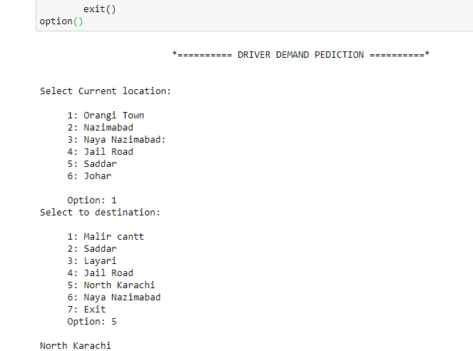

**Figure 1**

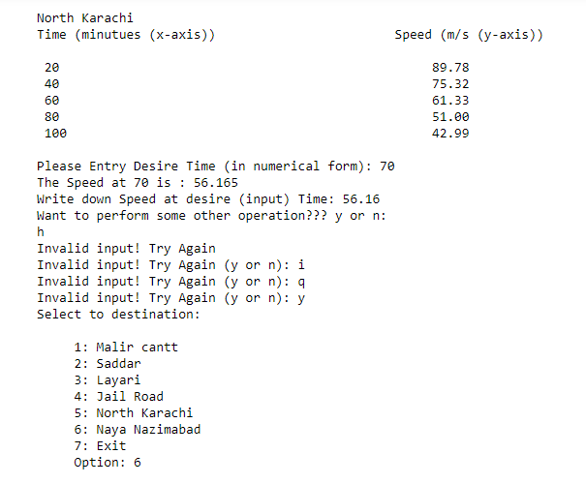

**Figure 2**

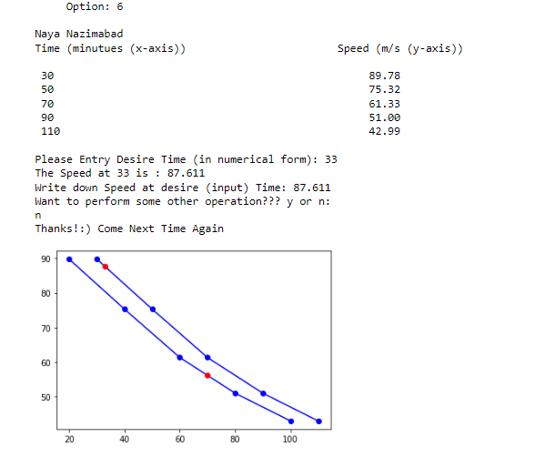

**Figure 3**